Deadline 10.1.20.3 User Guide

This document serves to provide general info and repeatable processes for both on-prem and cloud rendering.

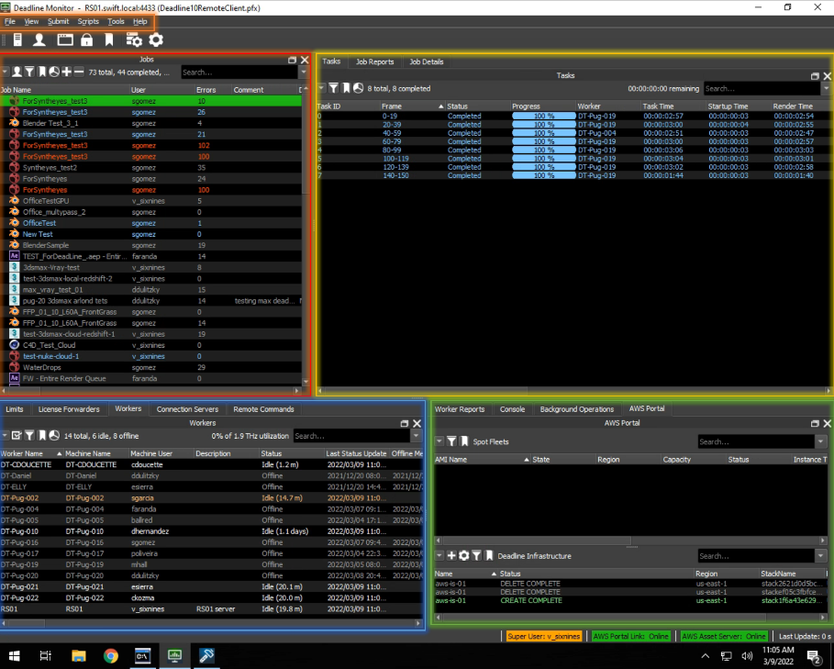
- File Menu
  - View
  - Submit
    - Job Submission
  - Tools
    - Manage Groups
    - Configure Repository Options
    - Configure Plugins
- Job Info
  - Resubmit a job
  - Modify Job Properties
  - View Job Reports
- Task Info
  - Job Details
- Diagnostic Info
  - Worker Reports
  - Console
  - Background Operations
  - AWS Portal
- Connection Info
  - Workers
- Deadline Installation
  - Database & Repository
  - Worker
  - UBL License Hours

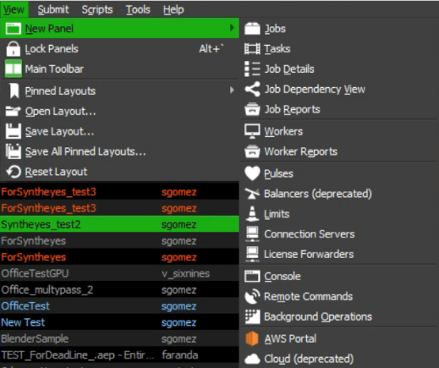
File Menu – View

This drop-down provides a way to save window layouts primarily,
this is used to repopulate the AWS Portal window after logging out.

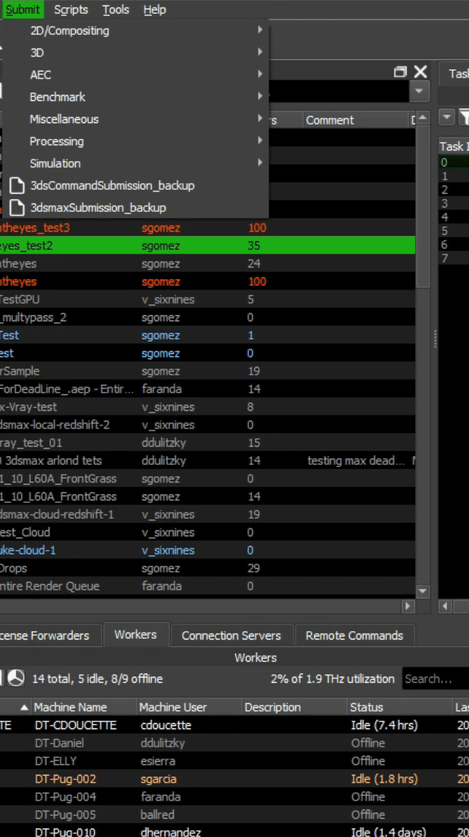
File Menu – Submit
The Submit drop-down is a list of options that launch individual Deadline Job scripts. This drop-down is updated as the Deadline Monitor gains support for more applications. See more here.

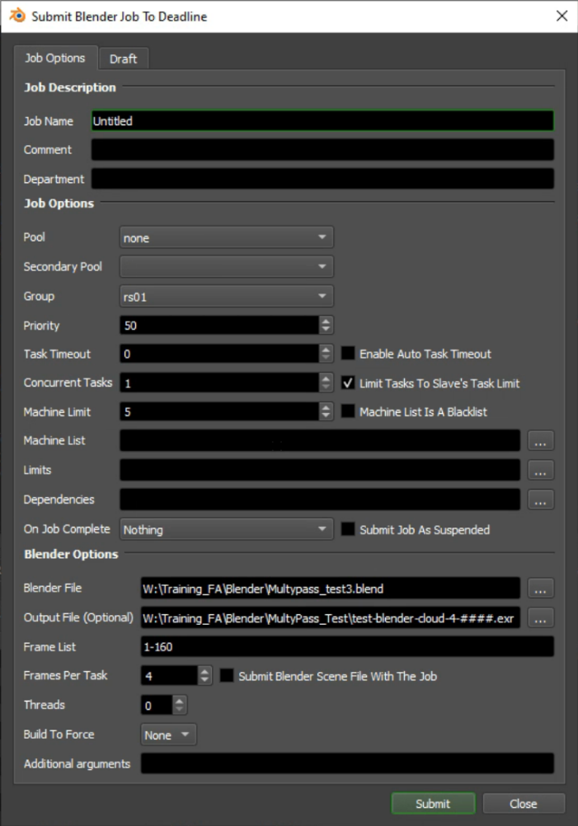
File Menu - Job Submission
There are three common sections of a job submission menu. Job Description, Job Options, and Program Options. The Job Description describes the job and its parameters, Job Options sets what resources are set to be used, and the program-specific options contain a variety of different settings for handling input and output. The versions of the created file and on worker machines have to be the same.
Job Options
- Pool – This refers to a “Pool” of machines that you would use in a render group.
- Group – This categorizes the computers that are dedicated to specific programs.
- Machine List – Consider this a white / blacklist for filtering out machines that might have Blender but not the specific version that was used to build the task.

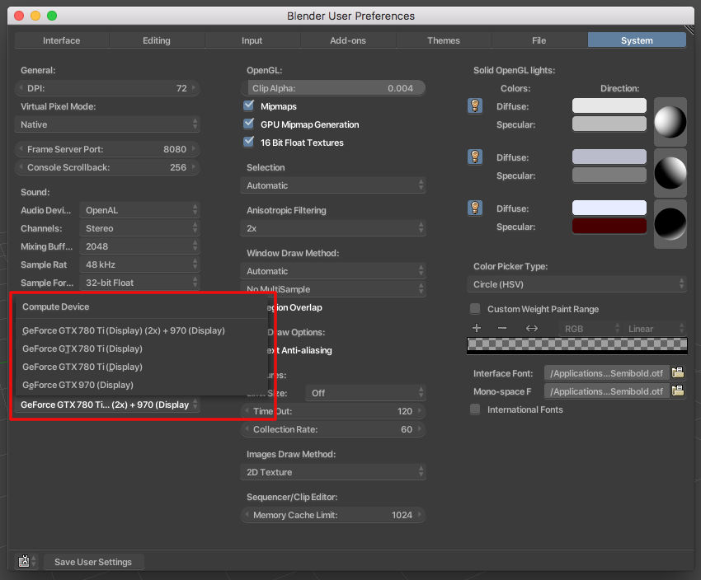
Blender
Blender’s cloud instances do not require licenses to run, as it is a free program. Deadline does not set any Blender specific settings from the original rendered file on other workers. Each individual Deadline worker has to be configured in the Blender program itself.

Blender Options
- Blender File – The value passed in is the direct location of the file that is being rendered.
- Output File – This value can be passed in with the pound sign to translate over values from the original render.
- Frame List – This specifies the frames rendered by deadline workers.
- Frames Per Task – These frames make up the sections workers will be rendering in a job.

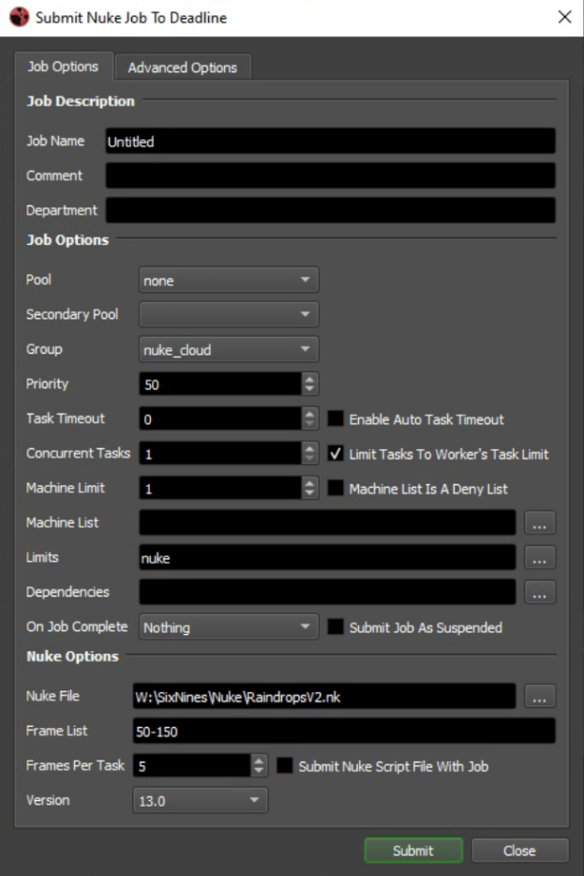
Nuke
Unlike Blender, these cloud instances require a Nuke license. This Deadline setup uses Nuke Interactive licenses.
Job Options
- Limits – This is used to set the number of licensed workers.
Nuke Options
- Nuke File – The value passed in is the direct location of the file that is being rendered.
- Frame List – This specifies the frames rendered by deadline workers.
- Frames Per Task – These frames make up the sections workers will be rendering in a job.
- Nuke Version – As above, make sure this aligns with the creator and worker version.

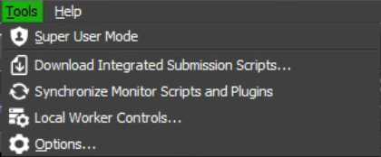
File Menu - Tools
Super User Disabled
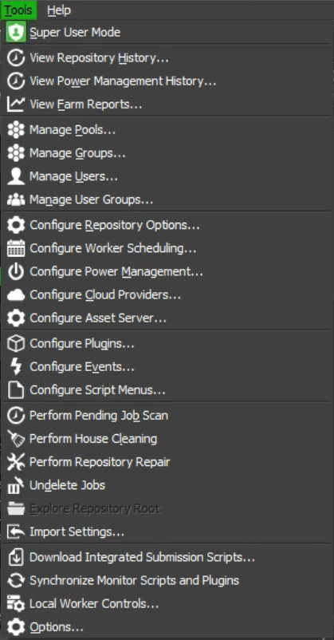
The Tools drop-down contains all the advanced configuration of Deadline, from Cloud configuration to job debugging to managing worker connections. We’ll be focusing on Manage Groups, Configure Repository Options and Configure Plugins.

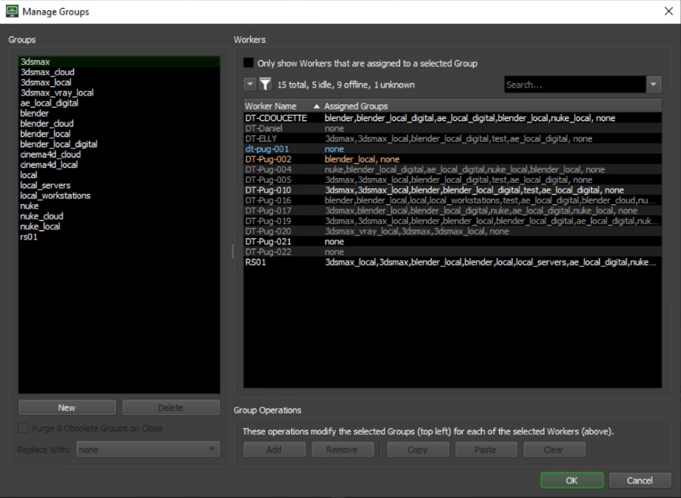
Manage Groups
- Groups – This menu is used to create and manage groups.
- Workers – Each on-prem worker has assigned groups relative to the programs installed.

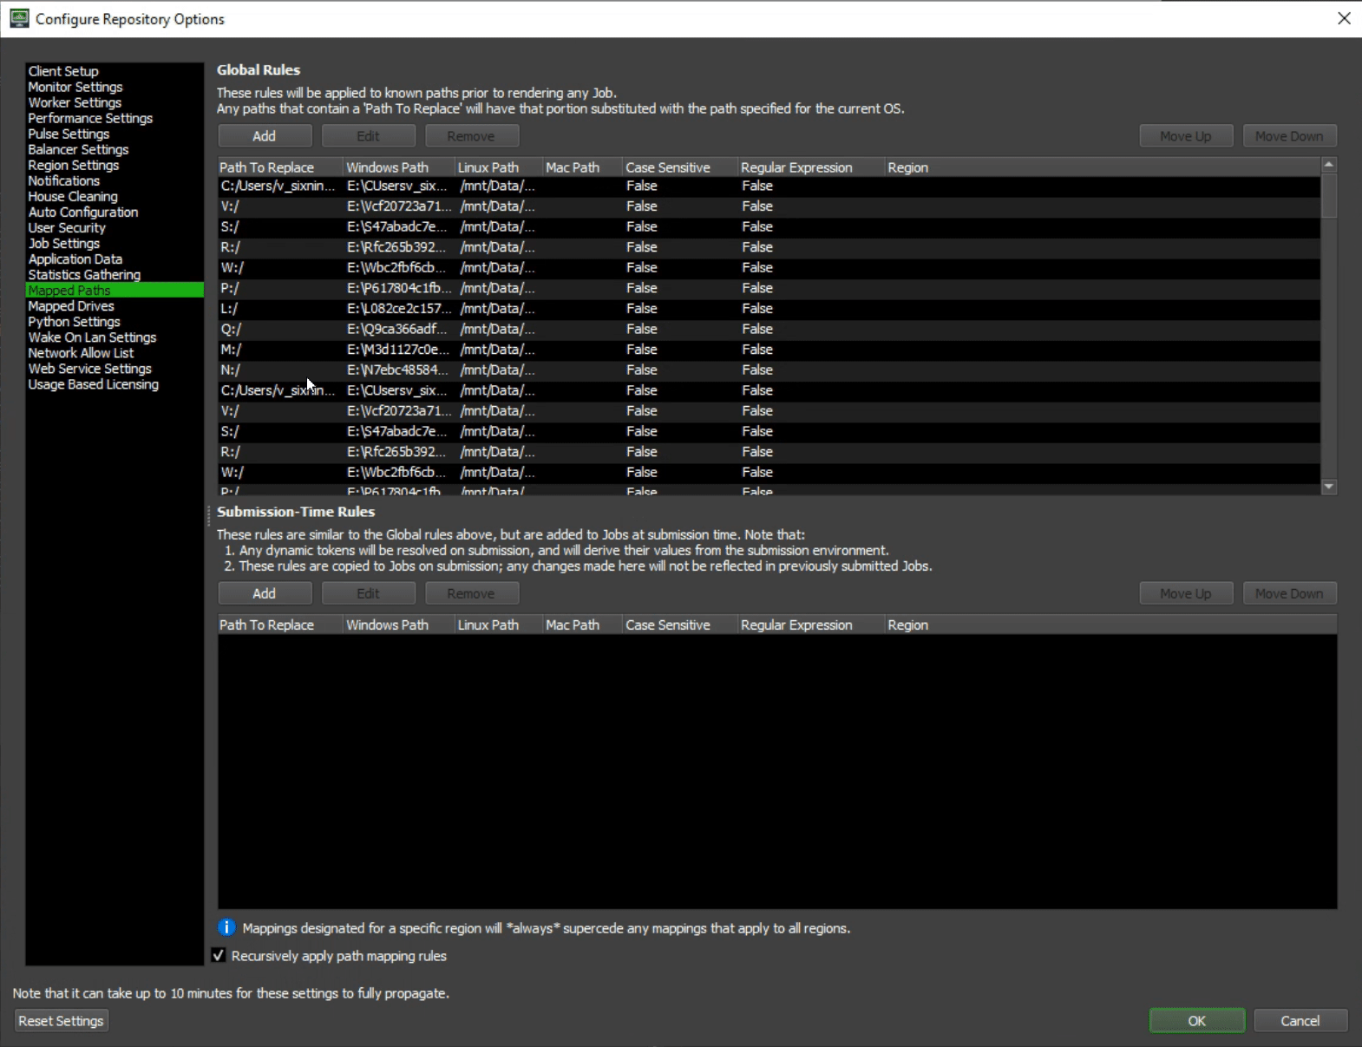
Configure Repository Options
This modal window has quite a few options; we’ll be focusing on Mapped Paths, Mapped Drives, and Usage Based Licensing.
- Mapped Paths – This section is filled with autogenerated region-based windows paths according to the Mapped Drives specified.
- Mapped Drives – This section creates a connection from Deadline to remote drives in other machines.
- Usage Based Licensing – This is directly related to the licensing bought in the Thinkbox Marketplace. As described, you fill in your URL and Activation Code, and the Cloud License Server checks if your cloud workers use a program under their UBL Hour consideration. More information can be found here.

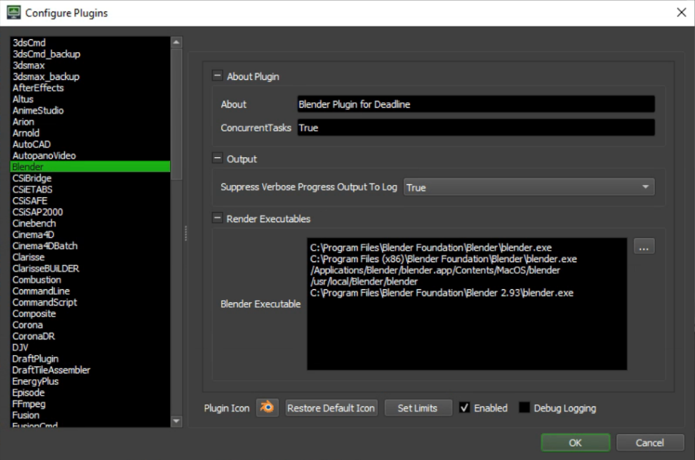
Configure Plugins
This modal window holds the information necessary for Deadline to locate the program files of each version of plugin on each operating system. This also holds Deadline’s program-specific configuration for third-party plugins. More info can be found here.

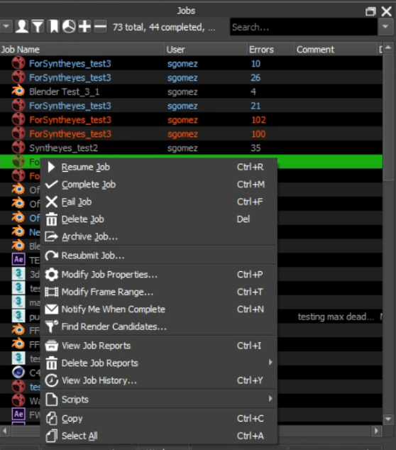
Job Info
This menu allows you to get more granular info about the configuration and Job reports. Whether you want to resubmit a job to reset failed tasks, modify the job properties to use a different group of workers, or view the communication that a job provides to Deadline itself on completion, this menu will provide transparency.

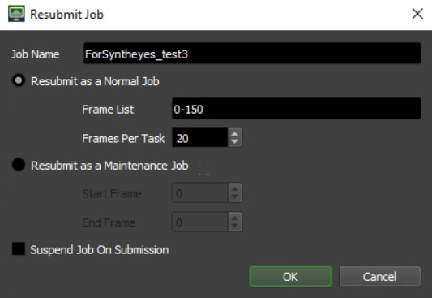
Resubmit Job
This modal window allows for resetting and changing the speed and frames at which a job processes data. More info about Job submissions can be found here.

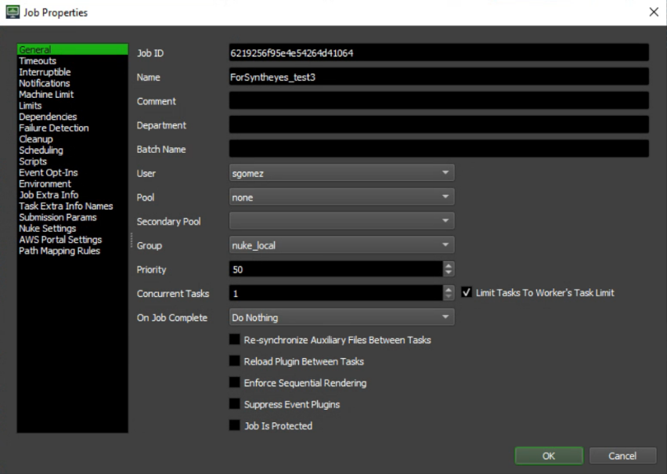
Modify Job Properties
This modal contains all the information included in a job submission. From the user who submitted it to the UBL limits, to the program-specific rendering options and base-level job parameters submitted by Deadline, this menu has all the references that might be mentioned in an error.

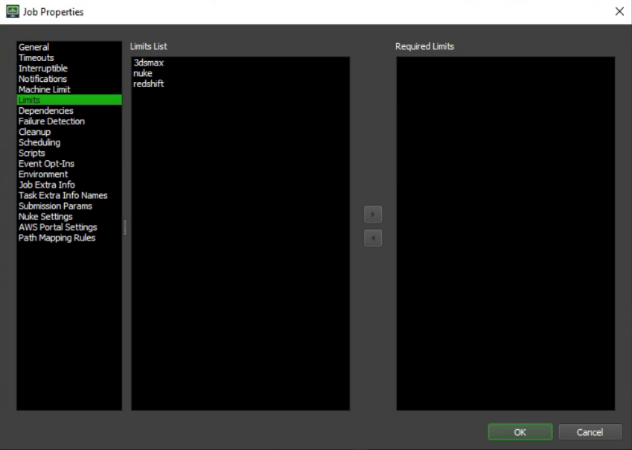
Modify Job Properties – Limits
The Limits section of the Job Properties window will be relevant once you’re working with UBL-based cloud instances. This implementation of Nuke has on-prem workstations using their own Interactive licenses, with Nuke UBL hours for in-cloud processing. This job has been used for testing the Nuke_Local Group, and as such doesn’t have nuke in the “Required Limits” section. This section gets automatically set when creating the job, but on second glance will tell you if a job isn’t using a limit it needs.

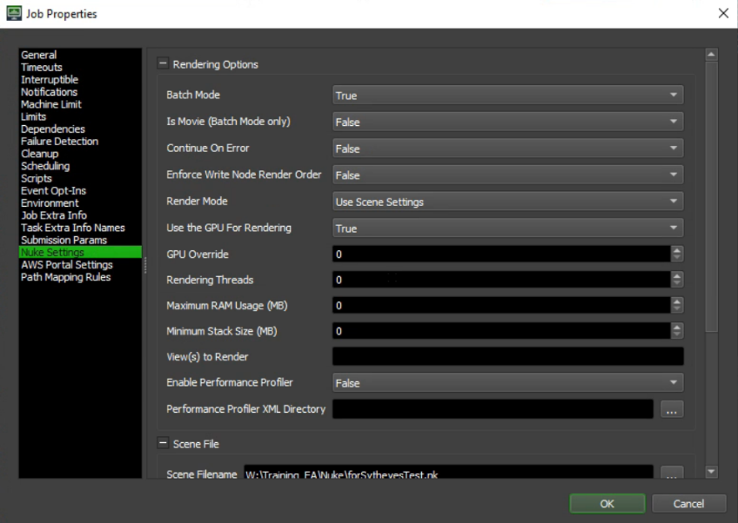
Modify Job Properties – Nuke Settings
Each Job Properties window will hold a different set of settings in this section, these can be set pre-emptively via the parameter section of the job submission window. More info can be found here.

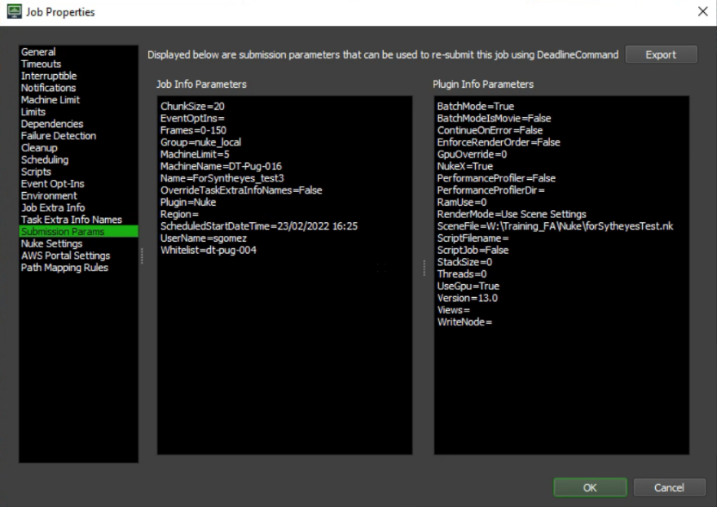
Modify Job Properties – Submission Params
This is an easy way of viewing the parameters submitted when the job was created. Access to network drives or versions can all be exported here as well. More info can be found here.

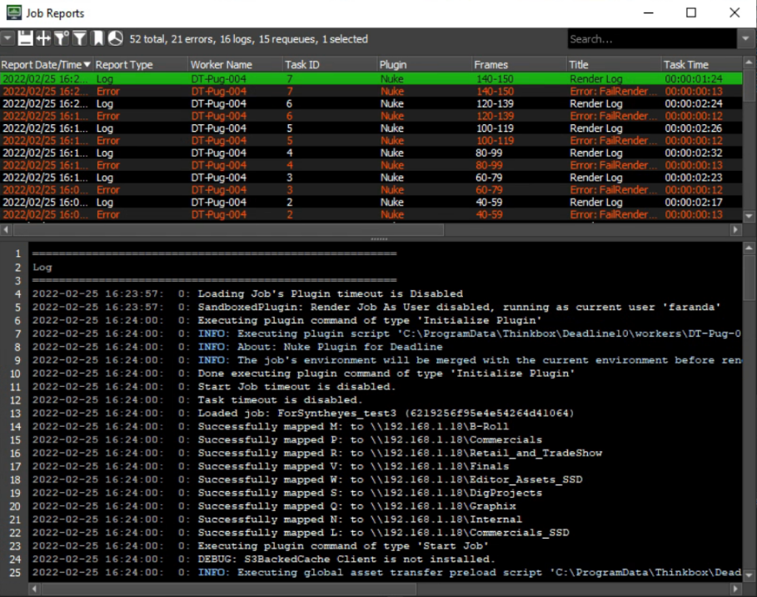
View Job Reports
This is an easy way of viewing the worker responses to specific tasks. This log is the primary place to debug oncoming errors. This log is accessible through right clicking a worker in the workers menu and clicking “Connect To Worker Log”, as well as via View -> New Panel -> Job Reports and highlighting the specific job.

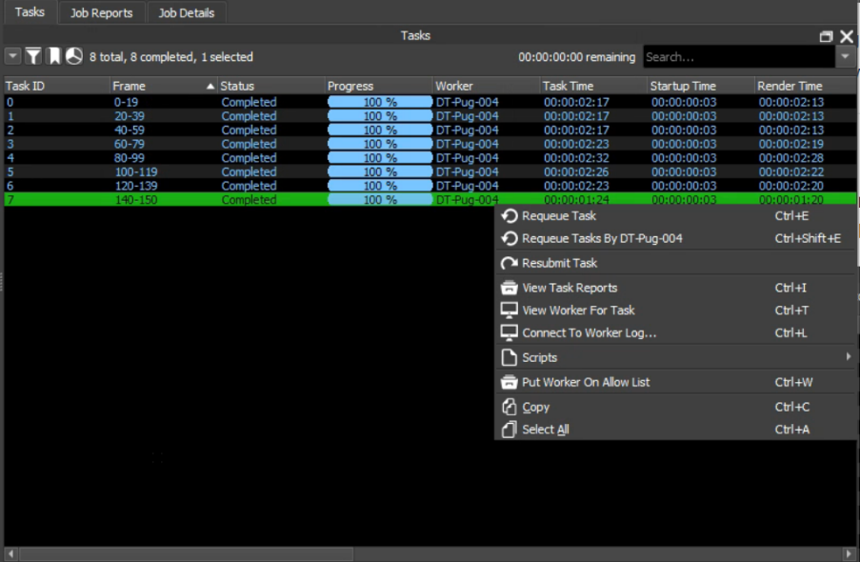
Task Info
This menu holds what worker is currently working on the specific frames, can show you worker logs as described previously and show the percentage of usage of CPU over time. Does not hold GPU usage as of 10.1.20.3.
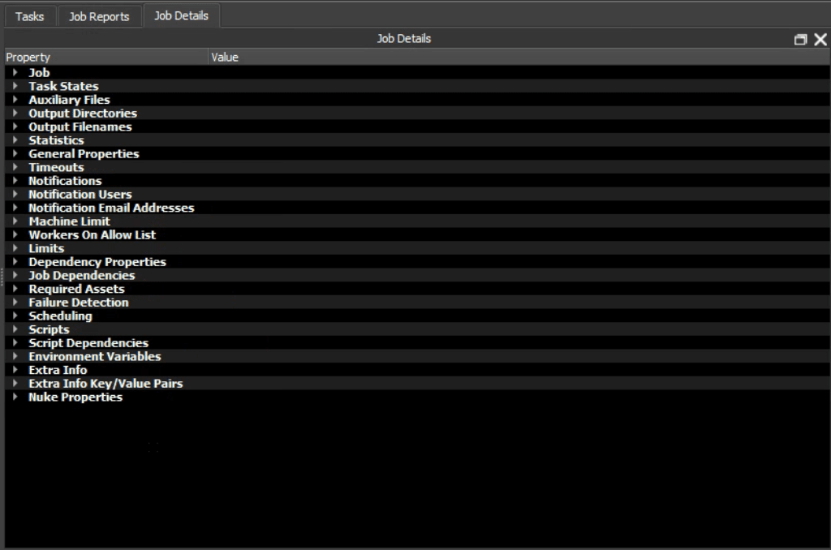
Task Info – Job Details
This is an easy way of viewing the job current details without scrolling horizontally through the Tasks menu. This also holds part of the info contained in the job properties modal window as well.

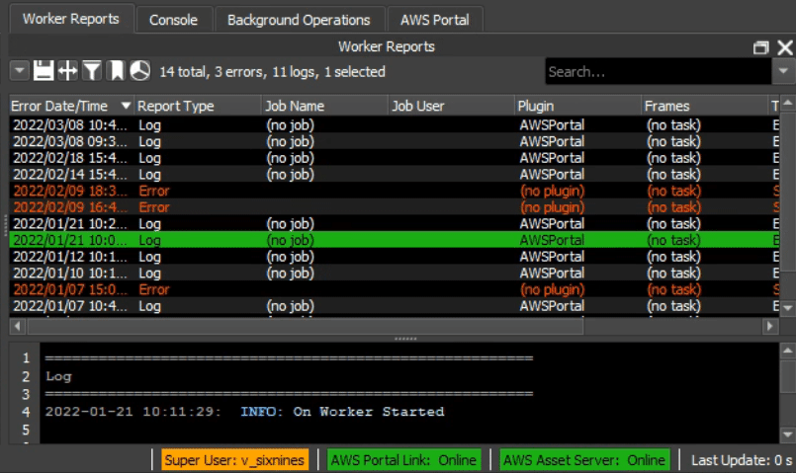
Diagnostic Info
These four windows are directly related to the Remote Connection Server and background operations within Deadline and the AWS Portal.

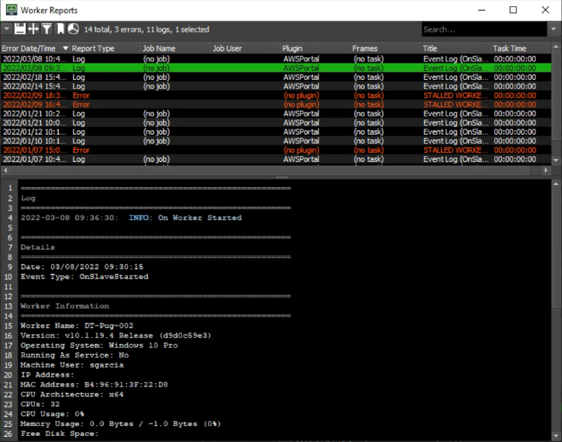
Diagnostic Info – Worker Reports
This modal menu showcases the AWS Portal Logs for starting and stalling workers. The AWS Portal will stall out workers after an amount of time of unuse, based on what you configure when you start the worker.

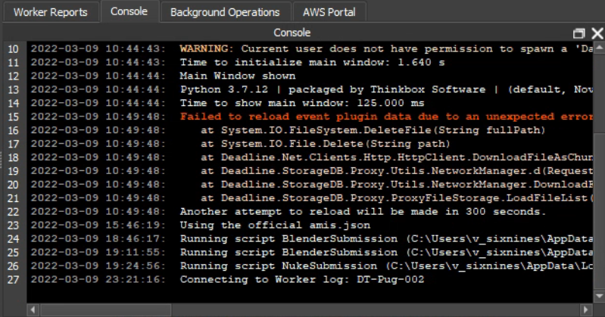
Diagnostic Info – Console
This modal menu showcases the Deadline Console, which is specifically the actions you take to monitor and configure workers within the Deadline interface. This applies to logs as well as showing that you are running Deadline scripts to launch jobs.

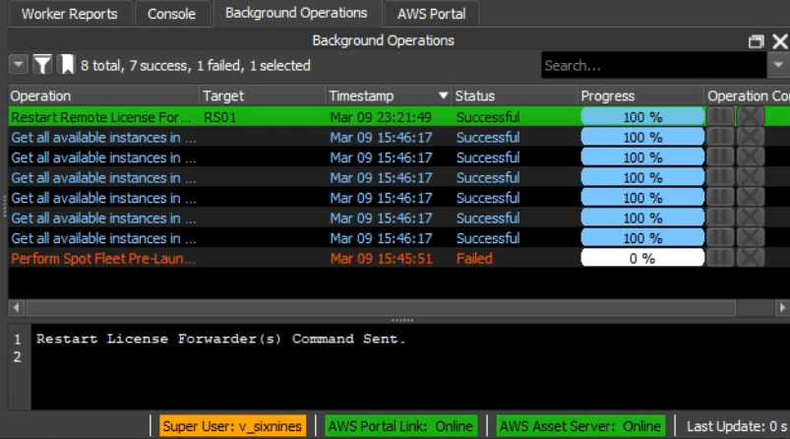
Diagnostic Info – Background Operations
This modal menu showcases the Deadline Background Operations, which will give you an up-to-date status of AWS Portal and License operations.

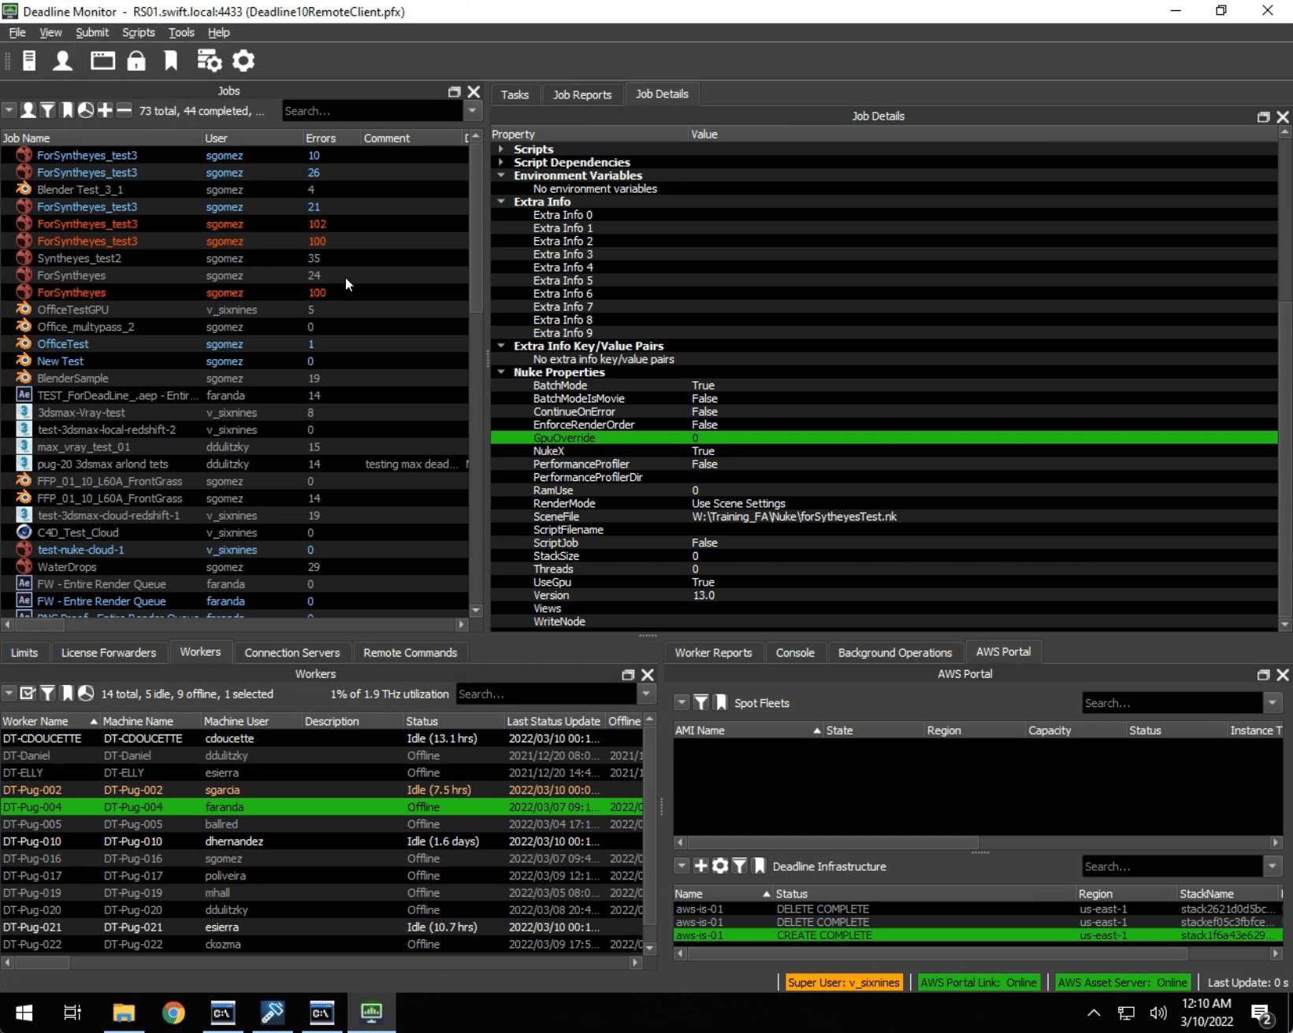
Diagnostic Info – AWS Portal
The AWS Portal handles launching AWS Spot Fleets. You can use the Spot Fleet Configuration menu to launch either Amazon-created AMIs (Amazon Machine Images) or AMIs you make yourself. It’s good practice to remove instance types that are $0.0 in the Instance Types section, because Deadline can try and pick that instance and fail. If you are successful, you should see a Spot Fleet created in the top region of the AWS Portal section. If you are not successful, the “AWS Portal Link: Online” button will turn red and require a login to refresh.
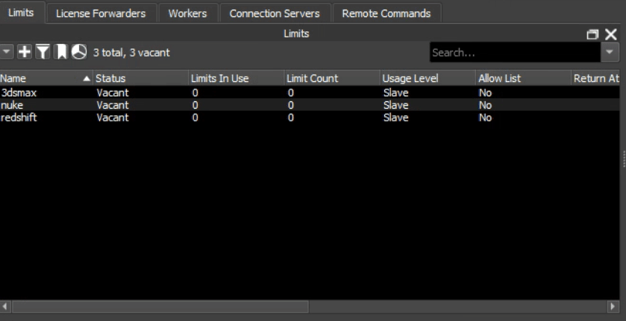
Connection Info
These are extraneous Deadline monitors, keeping track of UBL time, license forwarder system info, worker info, and the monitoring of the base Deadline Server itself. The Workers tab has been the most relevant debugging and changing out Groups depending on what programs they plan on using on-prem.

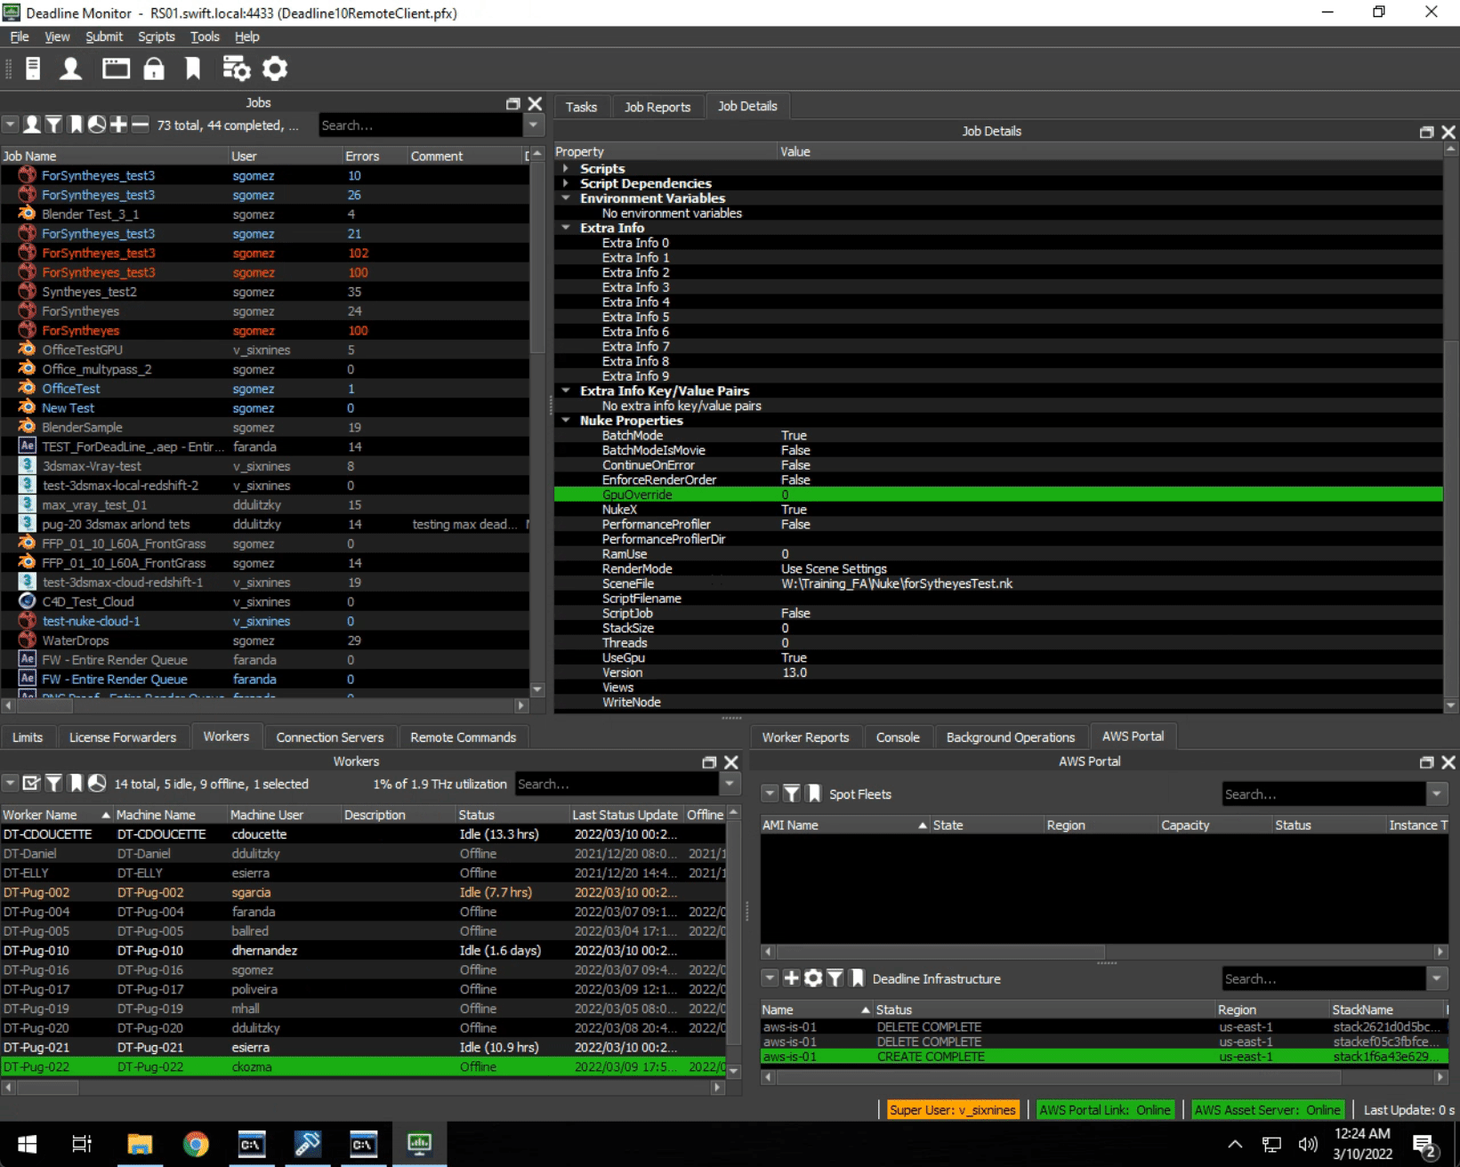
Connection Info – Workers
The “Workers” modal window provides access to worker modification. This can be used to restart workers on machines that you don’t have primary access to, change out groups and pools as need be, as well as keep track of usage in jobs.

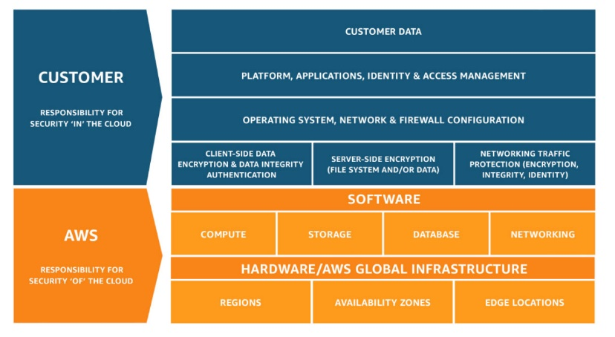
Deadline Installation
Deadline considers the AWS Shared Responsibility Model as it is relevant to security, network configuration, and hardware requirements. It is recommended that all rendering applications are installed on all render nodes. It is also recommended to store all assets in a network location to ensure all the workers in your render farm have access to the proper version of the file. More info on Render Farm recommendations can be found here.

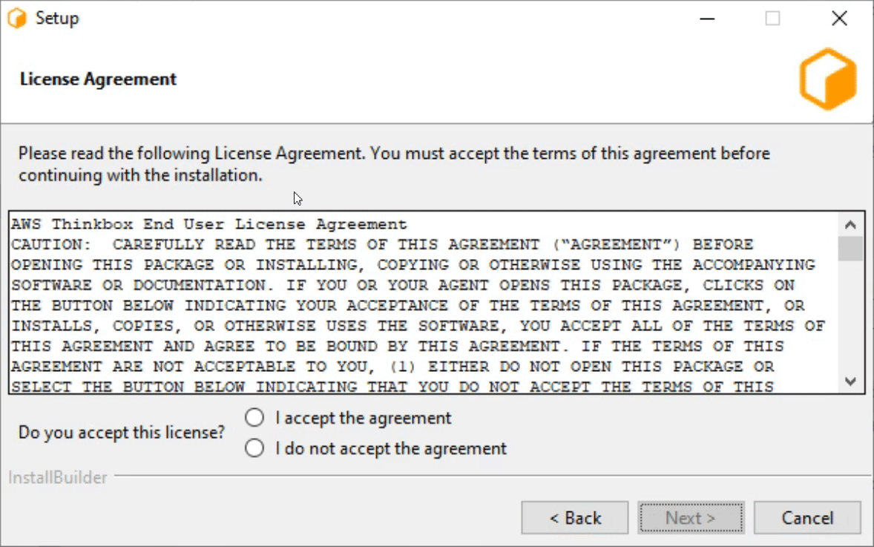
Deadline Installation – DB & Repository
This is the case for installing on top of an existing repository. Make sure all deadline processes are not active during this installation. We have discovered an issue with Secrets Management being enabled that prevents AWS launched AMIs from connecting.

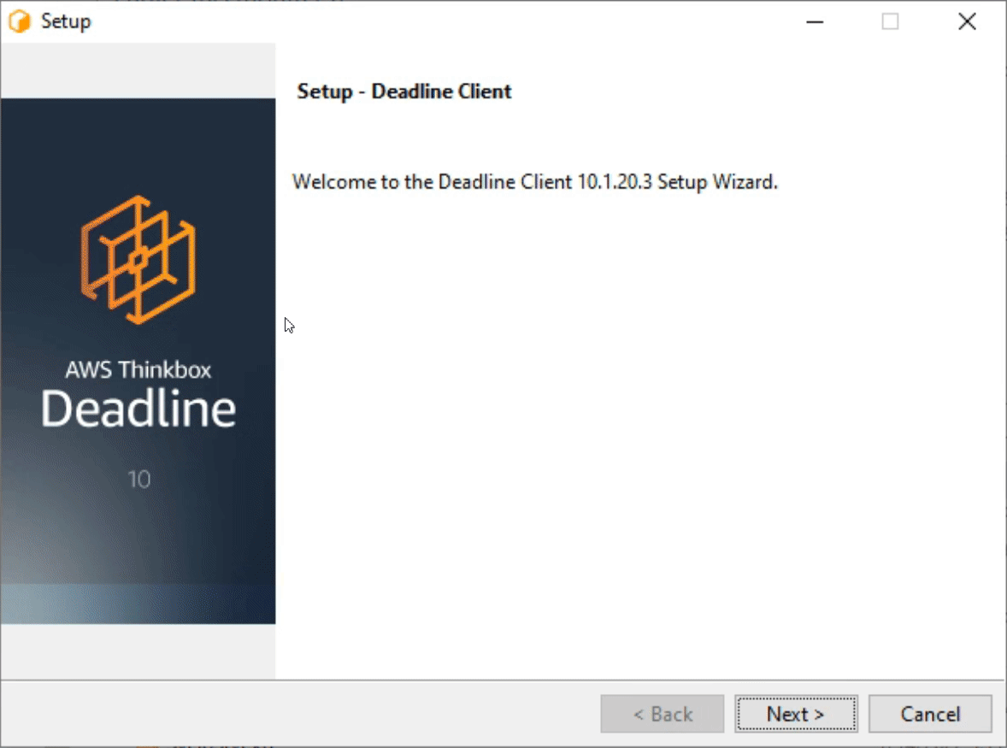
Deadline Installation – Worker
This is the case for installing a client on an on-prem worker. In this case, you’re connecting to a Remote Connection Server, something that is set up on RS01. If you want to install this on RS01, choose the option “Remote Connection Server” when the option appears.

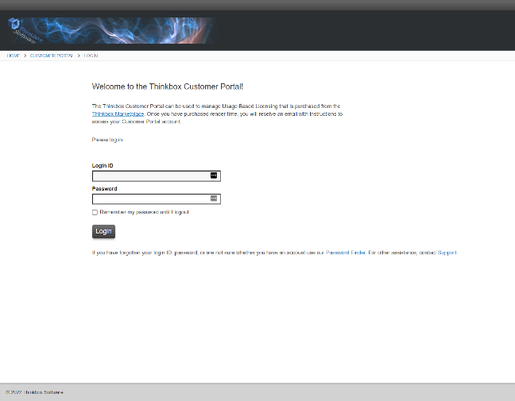
Deadline Installation – UBL Licenses
Usage-Based Licensing is used for rendering graphically intense programs with 3rd party products on-cloud. The Thinkbox Customer Portal will show your render time usage and view your Cloud License Server. It also includes the certificates necessary for Deadline to monitor the limits for each product while rendering on-cloud. More info here.

